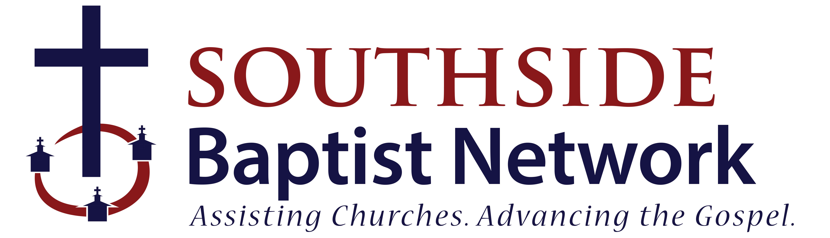

Request for Special Evangelistic Event Grant

Your Name: Role/Position:
Email: Phone:
Today’s Date: Date of Event:
Church Name:
Address:
Amount Requested: $
Event Title:
Provide a brief description of the event:
Anticipated attendance:
How many lost/unchurched people to you anticipate reaching through this event:
Describe your follow-up process for those who attend, make decisions, etc:
Have you done this evangelistic event in the past? Y N
If yes, describe results from previous events:
What is your anticipated budget for this event:
*Please attach a copy of event budget, if available.
Are you requesting and/or receiving funds from other sources? Y N
If yes, explain:

Submit to:
Southside Baptist Network
2170 Jonesboro Road
McDonough, GA 30253

